

[Department of Computer Science & Software Engineering](https://www.concordia.ca/encs/computer-science-software-engineering.html)

Software Process: SOEN341/4S---2016

Testing & Delivery

|  |  |
| --- | --- |
| The Schedulers | |
| Emili Vasseva | 27526741 |
| Sean Marcoux | 27511876 |
| Bruce Edouard Brazier | 27419562 |
| Dias Marat | 27277911 |
| Le Vinh Dang | 26844987 |
| Adriel Fabella | 27466005 |
| Gabriele Bavaro | 27399103 |
| Ying-Chen Chu | 27415710 |
| Alex Eladas | 27041462 |
| Salma Aly | 27176414 |
| Adil Hssaini | 24832396 |
| Nicolas Frazer-McKee | 27068956 |

Table of Contents

Grading Sheet.

1. Introduction 1

2. Testing Report 1

2.1 Test Coverage 1

2.1.1 Tested Items 2

2.1.2 Untested Items of Interest 2

2.2 Test Cases 3

2.2.1 Unit Testing 3

2.2.2 Requirements Testing 10

2.2.3 Stress Testing 20

2.2.4 Security Testing 27

3. System Delivery 28

3.1 Installation Manual 28

3.2 User Manual 40

3.3 Administrator Manual 47

4. Final Cost Estimate 48

**Grading Sheet**

|  |  |  |
| --- | --- | --- |
| Section | Evaluation criteria (see instructions in the template for details) | Grading |
| all | 10 marks are allocated for excellence, professionalism and quality of work above and beyond the correct meeting of specifications. | /10 |
| 1 | Presentation of the document | /5 |
| 2 | Introduction | /1 |
| 3.1 .  3.2  3.2.1  3.2.2  3.2.3  3.2.4 | Completeness of covered/uncovered items. Rationale of the importance of testing these items.  *Testing*  *Reproducibility of test cases. Exact description of test input data and expected results, and the procedure to convey all test cases. Description of the rationale for the derivation of each test case, e.g. equivalence partitioning analysis, branch coverage analysis, etc.*  *Unit testing*  Requirements testing:  Stress testing  *Security testing* | /3 .  /4  /8  /1  /1 |
| 4.1 .  4.2 | Clarity of instructions. Self-inclusion of the installation procedure, i.e. the installation does not necessitate the installation of external resources.  Clarity of instructions. Completeness of instructions, i.e. all system features’ usage instructions are provided. | /7 .  /7 |
| 5 | Completeness and clarity of cost to date in terms of person hours. | /3 |
| Total |  | /50 |

DO NOT REMOVE THIS PAGE WHEN SUBMITTING YOUR DOCUMENT

1. Introduction

The present deliverable details the testing and delivery processes that were undertaken to the completion of the scheduling system. In its first part it deals with the testing coverage in which all test items along with the test cases that were applied on them will be listed, as well as an explanation as to why testing is required. Two testable units are identified. The first one is the authentication which includes the log in and registration units, and the second one is the “manage Preferences” unit. Both were selected because of their priority and relevance to the overall system. A list of test cases is included for each unit in addition to the code to the stubs and drivers used. Extra tests are performed to show how the system is to be used and what system reactions are to be expected.

Stress and Security testing follow to evaluate the robustness and security levels of the system. Those tests shed light on the potential extreme situations of system usage and on its resistance to security concerns such as SQL injection attacks.

The report extensively explains the installation process. A manual listing what is needed and how it is to be installed is made available, and it guarantees a successful and functional system upon completion of the provided steps. It also describes how the system is to be used along with all its available features.

The report concludes with a revised cost estimate that compares what was previously forecasted and what was actually incurred.

2. Testing Report

**2.1 Test Coverage**

The following section covers the testing phase of the project. Testing is a key concept when it comes to the delivery of a particular product. The reason being is that it allows for the workers to assess the early problems in the software and to ensure that the requirements of top priority are managed, since these functionalities may endanger the overall software. The section is divided into different test categories:

* Tested Items
* Untested Items
* Unit testing
* Requirement testing

**Tested Items:** Defined as the features that were already tested. It results into two possible outcomes: pass or fail.

**Untested Items:** Defined as the features that were not already tested due to a specific reason which results into not prioritizing that particular matter.

**Unit Testing:** Defined as testing a small part of the software, in other words, a small part of the code is evaluated to see if it works.

**Requirements:** Defined as the essential functionality that a user, student and admin must be able to accomplish with the software at hand.

**2.1.1 Tested items**

The two units which were tested on consist of the authentication unit and the preference unit.

**Authentication**: This was immediately tested since the requirement of signing up and logging forms the basis of the whole use of the software. This consists of ensuring that the user is successfully directed to his/her appropriate page. This item is the number one priority because this functionality allows access to the Scheduler.

**Manage Preferences**: This unit was tested because the integration of preferences demands to be of creative thinker when generating the schedule. This is of great importance because the system’s requirement is to take into consideration the things that the student wants and testing solely on effectively containing, changing and deleting the preferences proves to be of big priority.

**Stress and Security**: This is an important key because the project, assuming it will be used by a certain client for a big academic institution, provides access to personal information. These tests are of importance since they provide a safety margin. Without protected and secure access, the software would suffer and, nonetheless the clients, since its functionality is overshadowed by not being secured and properly stressed.

|  |  |  |
| --- | --- | --- |
| **Student & Admin** | | |
| **Feature** | **Use Case** | **Related Test Cases** |
| **Login/Logout** | **UC1, UC2** | **1.1, 1.2, 1.3, 1.4, 2.1** |
| **Edit account information** | **UC5** | **19.1, 19.2, 19.3, 19.4, 19.5, 19.6, 19.7, 19.8** |

|  |  |  |
| --- | --- | --- |
| **Admin** | | |
| **Feature** | **Use Case** | **Related Test Cases** |
| **Add course to program** | **UC13** | **23.1, 23.2, 23.3** |
| **Delete course** | **UC14** | **25.1, 25.2** |
| **Edit course** | **UC15** | **24.1, 24.2** |
| **Add section** | **UC16** | **26.1, 26.2, 26.3, 26.4** |
| **Edit section** | **UC17** | **27.1, 27.2** |
| **Delete section** | **UC18** | **28.1** |

|  |  |  |
| --- | --- | --- |
| **Student** | | |
| **Feature** | **Use Case** | **Related Test Cases** |
| **Sign up** | **UC3** | **4.1, 4.2, 4.3, 4.4** |
| **Set preferences** | **UC6** | **12.1, 12.2, 12.3 12.4** |
| **Set needed courses** | **UC7** | **9.1, 9.2, 9.3, 9.4, 9.5, 9.6, 9.7** |
| **Delete needed courses** | **UC8** | **10.1** |
| **Set taken courses** | **UC9** | **8.1, 8.2, 8.3, 8.4** |
| **Delete taken courses** | **UC10** | **11.1** |
| **Generate schedule** | **UC11** | **13.1, 13.2, 13.3** |
| **View auto-generated list of taken courses** | **UC12** | **7.1, 7.2, 7.3, 7.4** |

**2.1.2 Untested Items of Interest:**

**Remaining server calls:** There are server calls for obtaining all courses, sections, and user information as well as calls for updating all of that information and calls for generating the schedule. These calls can be unit tested the same way the other calls were. They are important to test because the user interface relies on the server calls behaving as expected. Whether they succeed or fail, they must do it in the way the UI would expect.

**The user interface:** This was user tested, but it was not tested programmatically because there is no official React unit testing framework. There are some open source frameworks that we did not look too much into because they are very new and are neither robust nor heavily tested. Unit testing a UI is also much more complicated than testing a single function that handles data. If we were to unit test, we would use one of the open source React unit testing frameworks and edit it as needed. It is important to test the UI because this is the user facing portion of the application. If this does not perform as expected, it is immediately apparent to the user and does not look professional. User testing does not always pick up on all of the bugs the same way a unit test does, so unit testing the UI would thoroughly verify that it performs as expected.

|  |  |
| --- | --- |
| **Student & Admin** | |
| **Reset Password** | **Too complex** |
| **Confirm email** | **Too complex** |
| **Delete schedule** | **Not implemented** |
| **Change section** | **Does not add anything to software** |
| **View default schedule** | **Does not add anything** |
| **Save schedule** | **Not implemented** |
| **Print schedule** | **Does not add anything to software** |
| **View schedule** | **Not implemented** |

|  |  |
| --- | --- |
| **Unit** | **Tested?** |
| **Login/Logout/Sign up** | **Yes** |
| **Manage courses** | **Yes** |
| **Manage preferences** | **Yes** |
| **Manage account information** | **Yes** |
| **Manage course DB** | **No** |
| **Generate Schedule** | **No** |

**2.2. Test Cases**

**2.2.1 Unit Testing**

For the unit testing we chose to test several important server calls. These are crucial because it is how the client side and server side of our application communicate. Without these working bug-free the application would not be able to do much.

All of the server calls interact with the database in some way, either to retrieve data or to update it. In order for testing to work consistently we needed a database that would be constant. For this we made a much smaller database purely for testing purposes. When running tests locally, this database will be used instead of the official one. That way we will know exactly what information is supposed to be stored in the database and can expect consistent results from our tests.

Laravel has an official unit testing framework, but it expects all of the mvc to be used. Since we replaced the view with React, this framework was not ideal. Instead we have our own testing script, coded in javascript that runs all of our tests. Neither the testing script nor the database will be included in the release version of our application, since they are only for testing.

For development we created a javascript object, realServerBridge, which we used to abstract all of the server calls. We used this to make the server calls when testing.

**Login:**

Our login server call is as follows:

|  |  |  |  |  |
| --- | --- | --- | --- | --- |
| **URL** | **Purpose** | **Type** | **Input** | **Returns** |
| /login | Login verification | POST | {username:’’, password:’’} | {"success":"true","username":"JASONB","isAdmin":"true"} |

It expects a JSON object including a username string and a password string. It will return a JSON object with a string holding the success state, the username, and a string saying whether or not the user is an admin. The test cases are as follows:

|  |  |  |
| --- | --- | --- |
| **Description** | **Input** | **Expected output that was tested** |
| Call is made with a username that exists in the database with the correct password for that user | {username: ‘User’, password:’password’} | success=’true’  username=’User’  isAdmin=’false’ |
| Call is made with a username that does not exist in the database (sending an empty username and password is treated the same way as this) | {username:’notauser’, password:’password’} | success=’false’ |
| Call is made with existing user, but the wrong password | {username:’User’, password:’notthepassword’} | success=’false |
| Call is made with the admin’s username and password | {username:’Admin’, password:’password’} | success=’true’  username=’Admin’  isAdmin=’true’ |

We tested by making the server calls and then verifying the output we received. No set up or tear down was needed to keep the test consistent.

**Set Preferences**

Users can specify preferences for their schedule, such as a desired course load or a day of the week they want free. The server call to update the preferences for a user is as follows:

|  |  |  |  |  |
| --- | --- | --- | --- | --- |
| **URL** | **Purpose** | **Type** | **Input** | **Returns** |
| /editpreferences | Edit user’s preferences | POST | {username:’’,cload:'',dayoff:'',preftime:''}} | {"success":"true","username":"JasonB","courseload":"5","dayoff":"Monday","preftime":"Mornings"} |

It expects a JSON object including strings for the username, course load, day off, and preferred time and will return a JSON object including the success state, as well as the info that was sent. Our client side of our project can handle invalid data entered for preferences by replacing it with default information, so for testing we were not concerned with that. The test cases are as follows:

|  |  |  |
| --- | --- | --- |
| **Description** | **Input** | **Expected result** |
| Call is made with a username that exists | {username:’Jason’, cload:’5’, dayoff:’Monday’, preftime:’Mornings’} | Data updated in the database |
| Call is made with a username that is not in the database | {username:’notauser’, cload:’5’, dayoff:’Monday’, preftime:’Mornings’} | Output:  success=’false’ |

For the first test case we had to also use the server call to retrieve the preferences in order to check that the information had actually been updated.

The methods for both cases expect a username in the cookies, so this had to be done as set up for the cases. This had to be removed for the tear down and the preferences had to be set back to blank values, so the tests could be consistent.

**Registration:**

Registration was important to test. If this didn’t work it could cause security issues or could make it so that people could not even sign up for the site and could never access it. The server call is as follows:

|  |  |  |  |  |
| --- | --- | --- | --- | --- |
| **URL** | **Purpose** | **Type** | **Input** | **Returns** |
| /register | Register user | POST | {username:’’, email:’’, password:’’} | {"success":"false","username":"SprinkKing","error":"usernametakenalready"} |

It expects a JSON object containing strings for the username, e-mail, and password and will return a JSON object containing strings for the success state, the username, and an error message. The success will be false only if a user with that username already exists. The error will be blank if the call was successful.

The test cases are as follows:

|  |  |  |
| --- | --- | --- |
| **Description** | **Input** | **Expected output that was tested** |
| Call is made with a new username | {username:’BatmanVsSuperman’, email:’justiceleague@gmail.com’, password:’password’} | success=’true’  Also the following login call should succeed, showing that the user was added in the database |
| Call is made with an existing username | {username:’Jason’, email:’jason@hotmail.com’, password:’password’} | success=false |

No set ups were needed. For tear down we had to remove the BatmanVsSuperman user from the database, so the test would work again next time.

**Running the tests**

All of the tests succeeded. Here was the console after they ran:

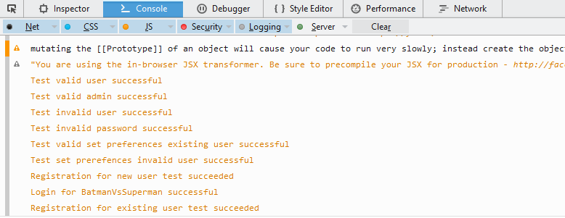

**Unit Testing Code**

For any server calls that expect information back from the server, a callback method must be sent to the server bridge object. This is due to the asynchronous nature of AJAX calls. When the data is finally received, it will be sent as the only argument to that method and then it can be tested. This is why we send functions as an argument for the server bridge methods.

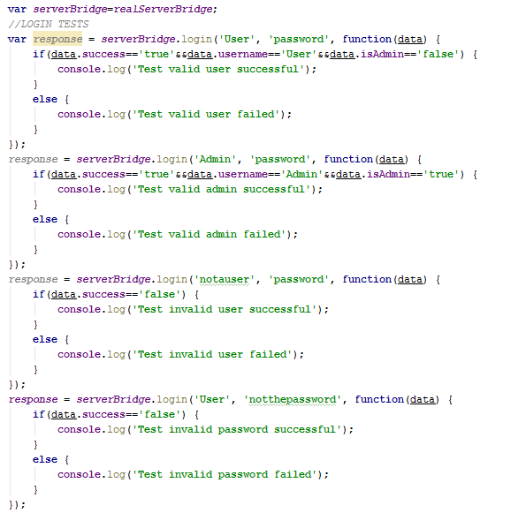

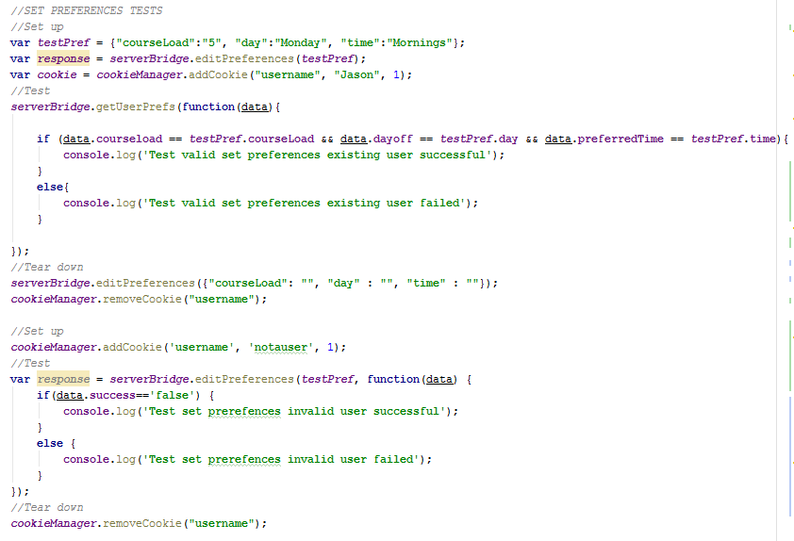

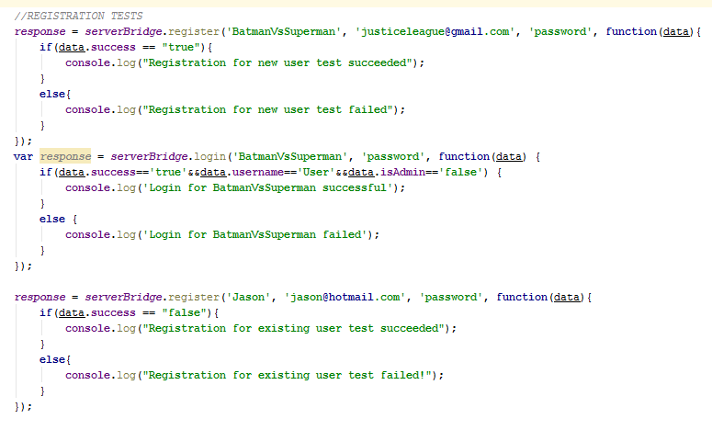

**2.2.2 Requirements testing**

The tables below show the result of black box testing for the functional requirement of the schedule generator system. Cells highlighted in green indicate a passed test while the ones in red indicates a failure. Failures are currently being investigated to be fixed for the final deliverable v1.2

Cases that were scoped out and therefore not tested are indicated in the last table

|  |  |  |  |  |  |
| --- | --- | --- | --- | --- | --- |
| **UC1** | **Login** | | | | |
| **ID** | **Description** | **Expected Output** | **Result** | **Bug ID** | **Comments** |
| **1.1** | **User inputs valid username and password (matching inputs)** | **User is redirected to student main page** | **PASS** |  |  |
| **1.2** | **User inputs a valid password and "admin" username** | **User is redirected to admin main page** | **PASS** |  |  |
| **1.3** | **User inputs invalid username and/or password** | **"Incorrect password and/or username"** | **PASS** |  |  |
| **1.4** | **User tries to login with one of the fields empty** | **"Incorrect password and/or username"** | **PASS** |  |  |

|  |  |  |  |  |  |
| --- | --- | --- | --- | --- | --- |
| **UC2** | **Logout** | | | | |
| **ID** | **Description** | **Expected Output** | **Result** | **Bug ID** | **Comments** |
| **2.1** | **User clicks on "logout" button** | **User is redirected to student main page** | **PASS** |  |  |

|  |  |  |  |  |  |
| --- | --- | --- | --- | --- | --- |
| **UC4** | **Sign up** | | | | |
| **ID** | **Description** | **Expected Output** | **Result** | **Bug ID** | **Comments** |
| **4.1** | **User inputs valid username, email and password.** | **Account is created and the user is redirected to the preferences page in their new account** | **PASS** |  |  |
| **4.2** | **User inputs a valid password and username, but an invalid email.** | **Error Message displayed asking user to enter a valid email** | **FAIL** | **2** | **To be fixed for v1.2** |
| **4.3** | **User inputs a valid password and email, but an invalid username.** | **Error Message displayed asking user to input a username with 4-6 characters** | **PASS** |  |  |
| **4.4** | **User inputs "admin" as a username, with a valid password and email.** | **Error message appears notifying user that the username entered is invalid** | **PASS** |  |  |

|  |  |  |  |  |  |
| --- | --- | --- | --- | --- | --- |
| **UC7** | **View auto-generated list of taken courses** | | | | |
| **ID** | **Description** | **Expected Output** | **Result** | **Bug ID** | **Comments** |
| **7.1** | **User inputs a valid number of semesters taken (between 1 and 7) and selects “generate course list”** | **A pop-up asking for confirmation to generate the course list is displayed.** | **PASS** |  |  |
| **7.2** | **User selects “Yes” in the pop-up prompting for confirmation to generate the course list** | **The pop-up closes and courses are auto-generated and added to the list of taken courses** | **PASS** |  |  |
| **7.3** | **User selects “No” in the pop-up prompting for confirmation to generate the course list** | **The pop-up closes and the input to “semesters taken” is blank.** | **PASS** |  |  |
| **7.4** | **User inputs an invalid number of semesters taken (not between 1 and 7) selects “generate course list”** | **An error message is displayed and the “generate course list” option doesn’t do anything.** | **PASS** |  |  |

|  |  |  |  |  |  |
| --- | --- | --- | --- | --- | --- |
| **UC8** | **Set taken courses** | | | | |
| **ID** | **Description** | **Expected Output** | **Result** | **Bug ID** | **Comments** |
| **8.1** | **User selects the “add class” option for the taken courses list** | **User is presented with a pop-up box prompting for an input of a course number or an input of a course name** | **PASS** |  |  |
| **8.2** | **User inputs a valid (present in the database) course number and selects “add class”** | **The course name corresponding to the course number is automatically generated. The pop-up box closes, and the inputted course is added to the list of taken courses** | **PASS** |  |  |
| **8.3** | **User inputs a valid (present in the database) course name and selects “add class”** | **The course number corresponding to the course name is automatically generated. The pop-up box closes, and the inputted course is added to the list of taken courses** | **PASS** |  | **Fixed v1.1** |
| **8.4** | **User inputs a valid (present in the database,) course number and/or course name already in the list of taken courses and selects “add class”** | **An error message is displayed and selecting the “add class” option doesn’t do anything.** | **PASS** |  |  |

|  |  |  |  |  |  |
| --- | --- | --- | --- | --- | --- |
| **UC9** | **Set needed courses** | | | | |
| **ID** | **Description** | **Expected Output** | **Result** | **Bug ID** | **Comments** |
| **9.1** | **User selects the “add class” option for the needed courses list** | **User is presented with a pop-up box prompting for an input of a course number or an input of a course name** | **PASS** |  |  |
| **9.2** | **User inputs a valid (present in the database, does not conflict with another course time and the prerequisites are met) course number and selects “add class”** | **The course name corresponding to the course number is automatically generated. The pop-up box closes, and the inputted course is added to the list of needed courses** | **PASS** |  | **Fixed v1.1** |
| **9.3** | **User inputs a valid (present in the database, does not conflict with another course time and the prerequisites are met) course name and selects “add class”** | **The course number corresponding to the course name is automatically generated. The pop-up box closes, and the inputted course is added to the list of needed courses** | **PASS** |  |  |
| **9.4** | **User inputs a course number or course name that conflicts with the time of another course in the list of needed courses and selects “add class”** | **An error message is displayed and selecting the “add class” option doesn’t do anything.** | **FAIL** | **3** | **The check condition is not yet properly implemented**  **To be fixed for v1.2** |
| **9.5** | **User inputs a course number or course name for which the prerequisites are not met and selects “add class”** | **An error message is displayed and selecting the “add class” option doesn’t do anything.** | **FAIL** | **3** | **The check condition is not yet properly implemented** |
| **9.6** | **User inputs an invalid (not present in the database) course number and/or course name and selects “add class”** | **An error message is displayed and selecting the “add class” option doesn’t do anything.** | **PASS** |  |  |
| **9.7** | **User inputs a valid (present in the database, does not conflict with another course time and the prerequisites are met) course number and/or course name already in the list of needed courses and selects “add class”** | **An error message is displayed and selecting the “add class” option doesn’t do anything.** | **PASS** |  | **Fixed v1.1** |

|  |  |  |  |  |  |
| --- | --- | --- | --- | --- | --- |
| **UC10** | **Delete needed courses** | | | | |
| **ID** | **Description** | **Expected Output** | **Result** | **Bug ID** | **Comments** |
| **10.1** | **User selects the delete icon of a course in the list of needed courses** | **The course is removed from the list of needed courses** | **PASS** |  |  |

|  |  |  |  |  |  |
| --- | --- | --- | --- | --- | --- |
| **UC11** | **Delete Taken Courses** | | | | |
| **ID** | **Description** | **Expected Output** | **Result** | **Bug ID** | **Comments** |
| **11.1** | **User selects the delete icon of a course in the list of taken courses** | **The course is removed from the list of taken courses** | **PASS** |  |  |

|  |  |  |  |  |  |
| --- | --- | --- | --- | --- | --- |
| **UC12** | **Set Preferences: Related to (Modify Preferences)** | | | | |
| **ID** | **Description** | **Expected Output** | **Result** | **Bug ID** | **Comments** |
| **12.1** | **User selects his desired day off to be a specific day (Monday, Tuesday, Wednesday, Thursday, or Friday) from the drop down menu** | **The selected day is displayed as the desired day off** | **PASS** |  |  |
| **12.2** | **User selects his desired day off to be “none” from the drop down menu** | **“none” is displayed as the desired day off** | **PASS** |  |  |
| **12.3** | **User selects his preferred time of the day to be either “mornings”, afternoons” or “evenings” from the drop down menu** | **The selected preferred time of the day is displayed as the preferred time of the day** | **PASS** |  |  |
| **12.4** | **User selects his preferred time of the day to be “Any” from the drop down menu** | **“Any” is displayed as the preferred time of the day** | **PASS** |  |  |

|  |  |  |  |  |  |
| --- | --- | --- | --- | --- | --- |
| **UC13** | **Generate schedule** | | | | |
| **ID** | **Description** | **Expected Output** | **Result** | **Bug ID** | **Comments** |
| **13.1** | **User selects the “build schedule” option** | **User is directed to the schedule page, and multiple schedules are generated according to the preferences and needed courses.** | **FAIL** | **4** | **The scheduling algorithm does not yet properly generate schedules according to the inputs (preferences and needed courses) given** |
| **13.2** | **User selects an arrow on the schedule page to see a different generated schedule** | **Another generated schedule is displayed on the schedule page** | **PASS** |  | **Fixed v1.1** |
| **13.3** | **User selects “select this schedule” from the schedule page** | **User is directed to the sequence page. The selected schedule is displayed along with the user’s course sequence** | **FAIL** | **4** | **The user’s course sequence does not display the right data** |

|  |  |  |  |  |  |
| --- | --- | --- | --- | --- | --- |
| **UC19** | **Edit Account Information** | | | | |
| **ID** | **Description** | **Expected Output** | **Result** | **Bug ID** | **Comments** |
| **19.1** | **User changes the username by inputting a new valid username** | **Name is changed in the account management page** | **PASS** |  |  |
| **19.2** | **User tries to change the username by inputting the same current user name** | **Error Message notifying the user that the entered user name is the same as the old one** | **PASS** |  | **Fixed v1.1** |
| **19.3** | **User changes the username with a new user name that is too short (less than 4 characters)** | **Error message notifying the user that the username is too short** | **PASS** |  |  |
| **19.4** | **Change current email with a new valid email** | **New email appears on the user account information** | **PASS** |  |  |
| **19.5** | **Change current email with one that has invalid format** | **Error message appears asking the user to input a valid email address.** | **FAIL** | **2** |  |
| **19.6** | **Change Password by entering the correct current password and new password with 8-16 characters and retype the new password correctly** | **Password is changed** | **PASS** |  |  |
| **19.7** | **Change Password by inputting the same current password as the new one** | **Error message appears notifying user to enter a new password** | **PASS** |  |  |
| **19.8** | **Change password by entering the correct current one , entering a valid new one but mismatch in retyping the new one** | **Error message notifying the user that the passwords do not match** | **PASS** |  |  |

|  |  |  |  |  |  |
| --- | --- | --- | --- | --- | --- |
| **UC23** | **Add Course to Program (Administrator)** | | | | |
| **ID** | **Description** | **Expected Output** | **Result** | **Bug ID** | **Comments** |
| **23.1** | **Add a new course to list of courses offered** | **Course is added to the list of courses displayed** | **PASS** |  |  |
| **23.2** | **Add a course that already exists in the list of courses** | **Error message appears and**  **Course List is not changed** | **PASS** |  |  |
| **23.3** | **Add Course with wrong name format ex: (341soen)** | **Error message appears and**  **Course List is not changed** | **FAIL** | **5** |  |

|  |  |  |  |  |  |
| --- | --- | --- | --- | --- | --- |
| **UC24** | **Edit Course (administrator)** | | | | |
| **ID** | **Description** | **Expected Output** | **Result** | **Bug ID** | **Comments** |
| **24.1** | **Edit Course Description** | **Course description is changed** | **PASS** |  |  |
| **24.2** | **Edit Course Prerequisites** | **Course prerequisites changes** | **PASS** |  |  |

|  |  |  |  |  |  |
| --- | --- | --- | --- | --- | --- |
| **UC25** | **Delete Course (administrator)** | | | | |
| **ID** | **Description** | **Expected Output** | **Result** | **Bug ID** | **Comments** |
| **25.1** | **Delete an existing course from course list** | **Course is removed from the course list** | **PASS** |  |  |
| **25.2** | **Delete a course with ID not in the list** | **Error message appears and**  **Course List is not changed** | **PASS** |  |  |

|  |  |  |  |  |  |
| --- | --- | --- | --- | --- | --- |
| **UC26** | **Add Section (administrator)** | | | | |
| **ID** | **Description** | **Expected Output** | **Result** | **Bug ID** | **Comments** |
| **26.1** | **Create new section with valid inputs (ex:Name:UI, Location: H-563 Day:MW Time:16:15-17:30,Course Name:SOEN341,Semester:**  **W2016)** | **New Section is added to the list of sections of the required course** | **PASS** |  |  |
| **26.2** | **Create Section without inputting all the data** | **Error message appears notifying the user to complete the data required** | **PASS** |  |  |
| **26.3** | **Add Section with existing section name** | **Error Message appears notifying the admin that section already exists** | **PASS** |  |  |
| **26.4** | **Add section with the same date, time and location of an existing section** | **Error Message appears to notify admin that the section cannot be created** | **PASS** |  |  |

|  |  |  |  |  |  |
| --- | --- | --- | --- | --- | --- |
| **UC27** | **Edit Section (administrator)** | | | | |
| **ID** | **Description** | **Expected Output** | **Result** | **Bug ID** | **Comments** |
| **27.1** | **Edit the time of an existing section  (ex: SOEN 341, Time:18:00-19:00)** | **Section time is changed; new time appears in the section information** | **FAIL** | **6** | **To be fixed for v1.2** |
| **27.2** | **Edit the location of an existing section** | **Section location is changed; new location appears in the section information** | **FAIL** | **6** | **To be fid for v1.2** |

|  |  |  |  |  |  |
| --- | --- | --- | --- | --- | --- |
| **UC 28** | **Delete Section (administrator)** | | | | |
| **ID** | **Description** | **Expected Output** | **Result** | **Bug ID** | **Comments** |
| **28.1** | **Delete an existing section from the list of sections of a course** | **Section is removed from the list** | **PASS** |  | **Fixed v1.1** |

**Requirements Scoped out and therefore not tested:**

|  |  |  |
| --- | --- | --- |
| **Use Case Number** | **Description** | **Test Result** |
| **UC 5** | **View Default Schedule without creating an account** | **N/A** |
| **UC 6** | **Modify a generated schedule** | **N/A** |
| **UC 14** | **Save a generated schedule** | **N/A** |
| **UC 15** | **Delete a saved schedule** | **N/A** |
| **UC 16** | **Print a generated schedule** | **N/A** |
| **UC 17** | **View previously saved schedule** | **N/A** |
| **UC 18** | **Change a section in the schedule** | **N/A** |

**2.2.3 Stress Testing**

The system described throughout the scheduler’s deliverables is a system which, by the very nature of its usage, will experience varying degrees of client traffic: There will be varying volume of users logging in to the system during the day versus the middle of the night or the dates of class registration versus other days between or in the middle of any given semester. This volume of users will tend to be condensed during the same higher traffic times (i.e. during the day of course registration) and more spread out during other times. These periods of heavy load on the system can be simulated and exaggerated beyond normal operation the system with a script efficiency tool. The resulting stress test can be applied to a system in order to determine the robustness, response and availability of a correct behavior for any system that may experience variable operation. The generic test is a black box test that can be applied to any system algorithm. However, the particular programming language and methods are a good indication

For the purpose of this deliverable, Apache Benchmark (ab) along with a PHP code in order console in order to repeat multiple htpwas used as a dynamic software verification and validation method in order to produce repeatable testing with quantitative request times (connect, processing, waiting, and total), transferred bytes (total, HTML, and document) for a given number of requests to be performed and the number of requests that occur simultaneously. A greater number of requests may represent simply a longer period of time (a week vs an hour). However, if a greater number of these requests occur at the same time (concurrency) than what is normal, then we are implementing a stress test in which we can observe several of the stress related defects.

The dynamic apachebenchmark test the PHP code and the server by attributing a number –n of requests and a value –c for the amount of simultaneous requests to be performed on every component of the server. This test however simulates a single device sending requests; in order to simulate many more devices, each with their own number set of requests, a PHP code was added to the apachebenchmark tool in order to multitask a number –r of url request repetition performed by each client and their value –c for the list of simultaneous clients.

Thus we have –c concurrent clients requesting the url’s –r times each making each their –n requests with –c multiples.

This test is much more likely to lead to a failure of the code and an incident once that code runs causing an incident that may or may not be handled because of the larger number of simultaneous and total requests.

The PHP classes are: ezab and abrunner

class eZAB

{

static $version = '0.3-dev';

static $defaults = array(

// 'real' options

/// How much troubleshooting info to print. <, 3 and above prints response codes (404, 200, etc.), 2 /// and above prints warnings and info."

/// Real life testing seem to tell a different story though...

'verbosity' => 1, // -v verbosity

'children' => 2, // -c concurrency Number of multiple requests to make

'tries' => 10, // -n requests Number of requests to perform

'timeout' => 0, // -t timelimit Seconds to max. wait for responses

'auth' => false,

'proxy' => false,

'proxyauth' => false,

'target' => '',

'keepalive' => false,

'head' => false,

'interface' => '',

'respencoding' => false,

'httpversion' => CURL_HTTP_VERSION_NONE,

'cookies' => array(),

'skippercentiles' => false,

'extraheaders' => array(),

// 'internal' options

'childnr' => false,

'parentid' => false,

// the actual script path (self)

'self' => __FILE__,

'php' => 'php',

'outputformat' => 'text',

'haltonerrors' => true,

'command' => 'runparent' // allowed: 'helpmsg', 'versionmsg', 'runparent', 'runchild'

);

class ABRunner

{

static $version = '0.1-dev';

static $defaults = array(

// 'real' options

'label' => '',

'server' => 'http://localhost', // Server hostname (the prefix for urls below).

'urls' => 'index.php', // List of urls to test. Use double quotes around, separate them with spaces

'urlsfile' => '',

'repetitions' => 1000, // The number of times each client requests each url

'concurrencies' => '100 10', // List of concurrent clients to use

'dognuplot' => false,

'doaggregategraph' => false,

'ab' => 'ab',

'summary_file' => 'summary.txt',

'output_dir' => 'test_logs',

'sleep' => 1,

// 'internal' options

'verbosity' => 4,

'self' => __FILE__,

'outputformat' => 'text',

'haltonerrors' => true,

'command' => 'runtests',

'abopts' => array()

);

Failure to meet response time requirements.

The System cannot be evaluated without completing a quantitative process to measure the response. This shall follow with more explanation.

Failure to run using particular configurations of hardware, operating systems and external libraries.

-libraries, and proper server are a critical issue in the installation and proper functioning of the Laravel framework. The absence of key libraries, PHP 5.4, PHP composer, Apache and MySQL within a proper server database are critical to the functioning of the system. The system will simply not exhibit the functionality given by the library –without warning.

Failure to gracefully handle resource shortage.

The Laravel framework implemented with a Heroku engine has the ability allow the database manager to scale in and out as well as automatic scaling to accommodate a varying number of clients in order to avoid downtime.

Failure to make resources available when they are no longer required.

A failure in the responsiveness of the SQL database can result in a cascade of failed requests and may result in a failure of the apache software and reboot incident –this is due to No code limiting the frequency of requests by any one client once a failed request has been observed.

Failure to fully recover from its own failure state or that of a related system.

And inappropriate SQL query can result into a failure of apache’s ability to respond to incoming requests which could overload incident of the system.

A failure in the PHP Laravel or composer plugins can result in a failure to interpret the code other than a string.

Testing with ApacheBenchmark:

Single instances of a client requesting a specific number –n of times, of which –c are concurrent.

In the following tables, there are 4 different instances of these simple stress tests:

First the concurrency level was changed:

|  |  |  |  |  |  |  |  |  |  |  |
| --- | --- | --- | --- | --- | --- | --- | --- | --- | --- | --- |
| Server Hostname | | | | Document Length (bytes) | | | Server Software | | | |
| schedule-heroku.herokuapp.com | | | | 2 036 | | | Apache | | | |
| Concurrency level | | Time for tests  (ms) | | | | Complete Requests | | | Failed Requests | |
| 100 | | 15 807 | | | | 500 | | | 0 | |
| Total transferred  (bytes) | | | | HTML transferred (bytes) | | | Transfer rate  (Kbytes/sec) | | | |
| 1 104 000 | | | | 1 018 000 | | | 68.21 | | | |
| Connection Times  (ms) | | | | | | | | | | |
|  | min | | | | mean | | median | | | max |
| Connect | 22 | | | | 31 | | 30 | | | 815 |
| Processing | 60 | | | | 2663 | | 2937 | | | 3010 |
| waiting | 54 | | | | 1479 | | 1473 | | | 2999 |
| total | 92 | | | | 2694 | | 2967 | | | 3784 |
| Time to a percent of completion (ms) | | | | | | | | | | |
| 50 | | | 75 | | | | | 90 | | |
| 2 967 | | | 3 008 | | | | | 3 034 | | |

|  |  |  |  |  |  |  |  |  |  |  |
| --- | --- | --- | --- | --- | --- | --- | --- | --- | --- | --- |
| Server Hostname | | | | Document Length (bytes) | | | Server Software | | | |
| schedule-heroku.herokuapp.com | | | | 2 036 | | | Apache | | | |
| Concurrency level | | Time for tests  (ms) | | | | Complete Requests | | | Failed Requests | |
| 500 | | 17 995 | | | | 500 | | | 0 | |
| Total transferred  (bytes) | | | | HTML transferred (bytes) | | | Transfer rate  (Kbytes/sec) | | | |
| 1 104 000 | | | | 1 018 000 | | | 59.91 | | | |
| Connection Times (ms) | | | | | | | | | | |
|  | min | | | | mean | | median | | | max |
| Connect | 24 | | | | 36 | | 30 | | | 3030 |
| Processing | 50 | | | | 10 382 | | 10 412 | | | 17 918 |
| waiting | 50 | | | | 10 374 | | 10 404 | | | 17 915 |
| total | 80 | | | | 10 418 | | 10 444 | | | 17 949 |
| Time to a percent of completion (ms) | | | | | | | | | | |
| 50 | | | 75 | | | | | 90 | | |
| 10 444 | | | 14 218 | | | | | 16 511 | | |

And Secondly the Complete requests was changed more drastically:

|  |  |  |  |  |  |  |  |  |  |  |
| --- | --- | --- | --- | --- | --- | --- | --- | --- | --- | --- |
| Server Hostname | | | | Document Length (bytes) | | | Server Software | | | |
| schedule-heroku.herokuapp.com | | | | 2 036 | | | Apache | | | |
| Concurrency level | | Time for tests  (ms) | | | | Complete Requests | | | Failed Requests | |
| 20 000 | | 303 427 | | | | 100 000 | | | 0 | |
| Total transferred  (bytes) | | | | HTML transferred (bytes) | | | Transfer rate  (Kbytes/sec) | | | |
| 220 800 000 | | | | 203 600 000 | | | 68.06 | | | |
| Connection Times  (ms) | | | | | | | | | | |
|  | min | | | | mean | | median | | | max |
| Connect | 20 | | | | 32 | | 30 | | | 3 036 |
| Processing | 4 202 | | | | 570 449 | | 626 140 | | | 663 901 |
| waiting | 1 319 | | | | 317 062 | | 317 014 | | | 651 050 |
| total | 4 234 | | | | 570 481 | | 626 170 | | | 663 931 |
| Time to a percent of completion (ms) | | | | | | | | | | |
| 50 | | | 75 | | | | | 90 | | |
| 626 170 | | | 635 745 | | | | | 657 250 | | |

Reduced request by a factor of 10.

|  |  |  |  |  |  |  |  |  |  |  |
| --- | --- | --- | --- | --- | --- | --- | --- | --- | --- | --- |
| Server Hostname | | | | Document Length (bytes) | | | Server Software | | | |
| schedule-heroku.herokuapp.com | | | | 2 036 | | | Apache | | | |
| Concurrency level | | Time for tests  (ms) | | | | Complete Requests | | | Failed Requests | |
| 10 000 | | 313 216 | | | | 10 000 | | | 0 | |
| Total transferred  (bytes) | | | | HTML transferred (bytes) | | | Transfer rate  (Kbytes/sec) | | | |
| 2 204 000 | | | | 2 036 000 | | | 68.84 | | | |
| Connection Times  (ms) | | | | | | | | | | |
|  | min | | | | mean | | median | | | max |
| Connect | 20 | | | | 31 | | 30 | | | 3 032 |
| Processing | 1 1142 | | | | 159 379 | | 161 661 | | | 312 704 |
| waiting | 355 | | | | 158 748 | | 161 003 | | | 312 347 |
| total | 1 174 | | | | 159 410 | | 161 689 | | | 312 738 |
| Time to a percent of completion (ms) | | | | | | | | | | |
| 50 | | | 75 | | | | | 90 | | |
| 161 689 | | | 237 593 | | | | | 312 738 | | |

These tables only represent one instance of a client requestings –they would be variable depending on the server current capacity and load. These tests give very little indication as to how the system could be pushed past it’s limits.

In order to attempt this true stress testing, the PHP classes that multiply the number of imaginary clients and their requests were used to get and average responsiveness. The variables, -n, -r and –c were set in order to recreate 1000 students 10 or 1 at a time, each with 100 requests that are made 1 at a time.

It Should be noted that the server host was changed to http;//localhost:8000 –which reduced the connect times to virtually 0ms.

--------------------------------------------------------------------------------------------------------------------------

### Start Time: Wed, 06 Apr 2016 10:55:38 +0200

Testing http://localhost:8000/index.php, concurrency: 100, iterations: 100000

Command: ab -n 100000 -c 100 "http://localhost:8000/index.php"

This is ABRunner, Version 0.1-dev

### Start Time: Wed, 06 Apr 2016 12:36:22 +0200

Testing http://localhost:8000/index.php, concurrency: 100, iterations: 100000

Command: ab -n 100000 -c 100 "http://localhost:8000/index.php"

This is ABRunner, Version 0.1-dev

### Start Time: Wed, 06 Apr 2016 12:37:45 +0200

Testing http://localhost:8000/index.php, concurrency: 100, iterations: 100000

Command: ab -n 100000 -c 100 "http://localhost:8000/index.php"

Testing http://localhost:8000/index.php, concurrency: 10, iterations: 10000

Command: ab -n 10000 -c 10 "http://localhost:8000/index.php"

This is ABRunner, Version 0.1-dev

### Start Time: Wed, 06 Apr 2016 12:44:17 +0200

Testing http://localhost:8000/index.php, concurrency: 100, iterations: 100000

Command: ab -n 100000 -c 100 "http://localhost:8000/index.php"

This is ABRunner, Version 0.1-dev

### Start Time: Wed, 06 Apr 2016 12:47:04 +0200

Testing http://localhost:8000/index.php, concurrency: 1, iterations: 1000

Command: ab -n 1000 -c 1 "http://localhost:8000/index.php"

Testing http://localhost:8000/index.php, concurrency: 10, iterations: 10000

### End Time: Wed, 06 Apr 2016 13:02:12 +0200

---------------------------------------------------------------------

This is a total time of 2: 07: 26 for 3.2 Million requests: an average Of 419 requests every second. For the purpose of this large test the more detailed time keeping was turned off in order to save resources.

A shorter test was then used with no concurrency –this results in fewer requests per second, however a much smaller time to do each request.

---------------------------------------------------------------------------------------------------------------------------------

### Start Time: Wed, 06 Apr 2016 13:22:37 +0200

Testing http://localhost:8000/index.php, concurrency: 1, iterations: 100

Command: ab -n 100 -c 1 "http://localhost:8000/index.php"

Requests per second: 12.03 [#/sec] (mean)

Time per request: 83.128 [ms] (mean)

Failed requests: 0

Testing http://localhost:8000/index.php, concurrency: 10, iterations: 1000

Command: ab -n 1000 -c 10 "http://localhost:8000/index.php"

### End Time: Wed, 06 Apr 2016 13:24:13 +0200

---------------------------------------------------------------------------------------------------------------------------------

These tests give a brief view into the resource done by the server in order to give the best responsiveness in each situation.

**2.2.4 Security Testing**

SQL and HTML injection can be used to verify the security of a system and its capacity to leak important system information about the structure of the object oriented HTML/PHP or of the database schema; such as the exact HTML/PHP structure, Files, Extensions, Updates or even Database structure and contents. This is clearly an outcome to be avoided: thus a Laravel PHP framework was implemented in order to prevent eventual security breaches –especially by injection. The higher level abstraction of the frameworks helps to achieve this.

If this nikto is directly implemented into the server location, then many information is readily available:

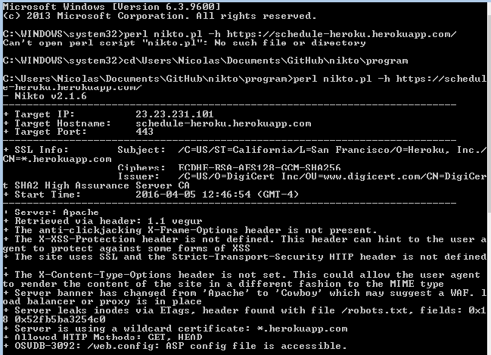

However, if the system is properly uploaded and the nikto is ran from outside the system, then no web server is detected at all.

3.System Delivery

**3.1 Installation Manual**

This installation manual will explain to an administrator how to install the scheduler system on a local hosting server. It is also possible to do it on a shared server, meaning the website would be accessible via the internet. However, this requires two things: a domain name and a shared server capable of running Laravel, such as https://www.fortrabbit.com/. Both cost a certain amount of money. However, the installation manual will only show how to install the project locally on the computer. The following installation is performed on Windows 10, but it is also possible to do it on other OS, with slightly modifications.

4 software are mainly required, with the scheduler project:

* WampServer
* Visual Studio
* Composer
* MySQL
* Scheduler Project from GitHub

**Step 1: WampServer Installation**

The first step consist of downloading and installing WampServer. WampServer contains all the needed softwares to run a PHP program on the local host: PHP, Apache and MySQL. It is recommended to download WampServer 2.5, containing especially Apache 2.4.9, MySQL 5.6.17, PHP 5.5.12. The scheduler has been coded in PHP 5.5, therefore it is preferred to use that version in case syntax modifications have been done in the newer versions of PHP 7. Furthermore, this package works both on 32-bit and 64-bit computers. The website to this download is http://www.wampserver.com/en/.

**Note:** Another alternative to WampServer is XAMPP. The only difference between both is that XAMPP is offered on multiple operating systems, such as iOS and Linux, in addition to Windows. WampServer is only offered for Windows.

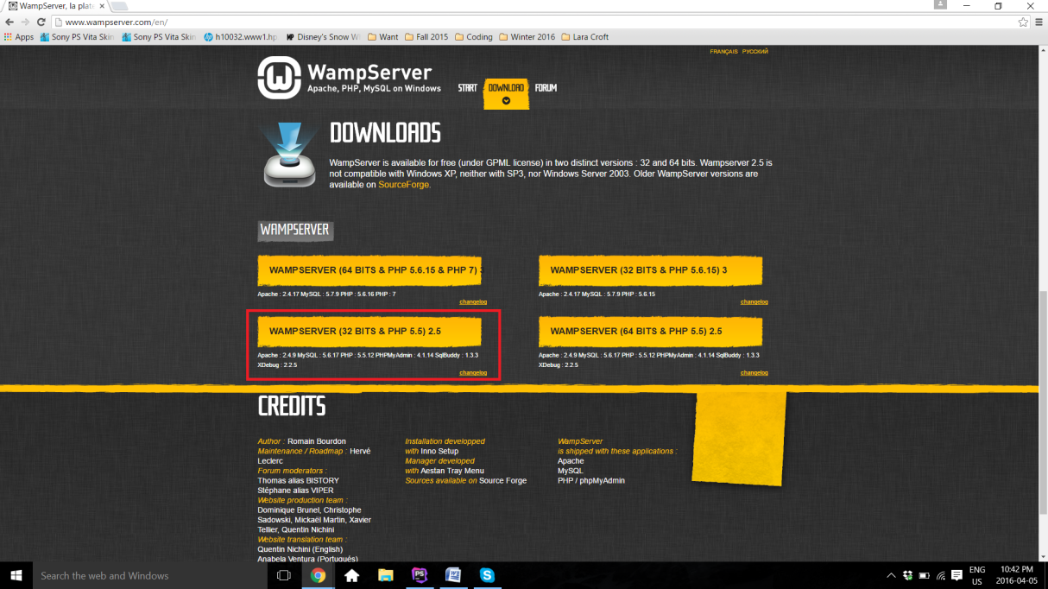

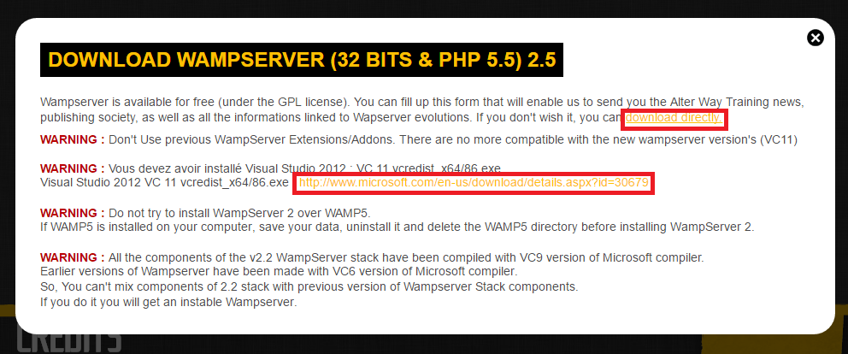

As shown here, there is a couple of warnings regarding WampServer. It is especially important to pay attention to second **warning**. In order for WampServer to work, Visual Studio is required. This is because Apache works along with Visual Studio. If Visual Studio 2012 is not installed on the computer, the administrator should click on the link https://www.microsoft.com/en-us/download/details.aspx?id=30679 found in the same warning. This opens a Microsoft download page for the correct version of Visual Studio. Once downloaded, Visual Studio can be installed. No special modification is required, therefore it is only necessary to follow the instructions displayed on Visual Studio installation window and click on **Next** a couple of times until the installation has begun, and proceeded successfully. It is important to note that there is a paid version of Visual Studio, but it is not required as the free version works equally well for the purpose of Apache.

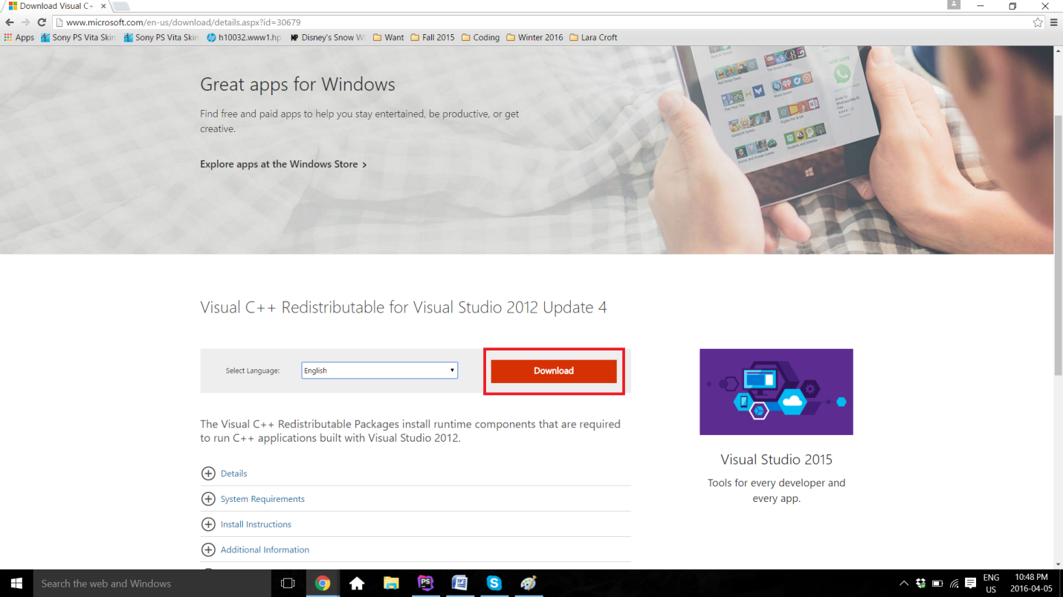

Once Visual Studio is set, the administrator can now go back to the WampServer website and click **download directly**. A new page from the website SourceForge will open, containing the file. A few seconds has to pass for the download to start. On Google Chrome, the download will be shown on the bottom left of the web page. After the download is completed, it is only sufficient to click on the file and the installation will begin. Otherwise, as any other downloads, the file has to be located to wherever downloaded files are usually saved (it is usually in the **Download** directory).

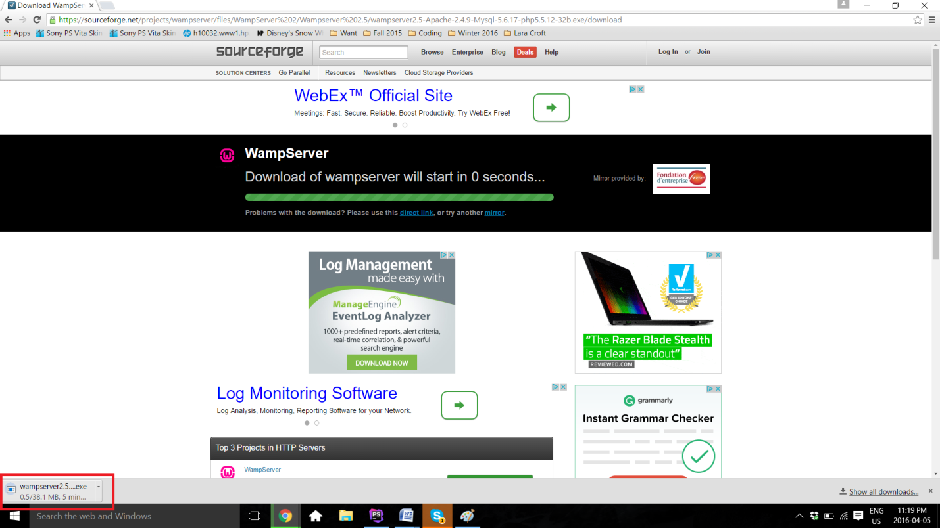

Once again, installing WampServer does not require any particular specifications or changes on the automatic procedure. The only thing required from the administrator is to keep track of where the software is installed. In this example, the software has been saved under **C:\wamp**.

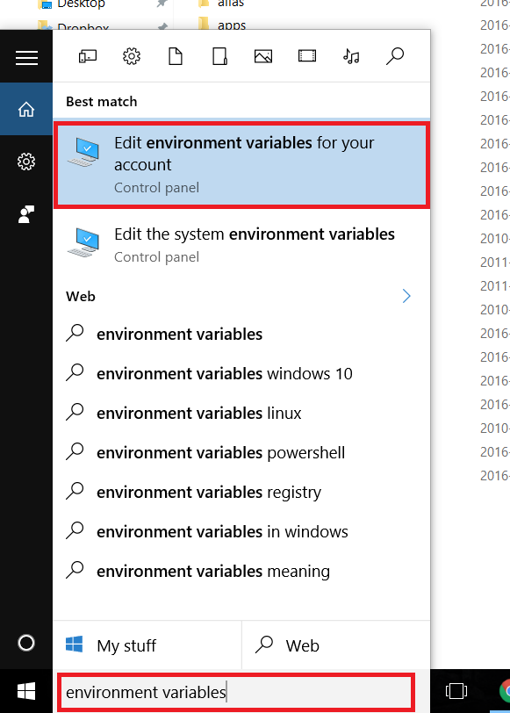**Step 2: Create the PHP and MySQL Path in the Environment Variables.**

This step enables the Command Prompt to have access to the PHP and MySQL, therefore being able to manipulate and launch the software from there later on in the procedure. First, it is possible to find the Environment Variables by typing the name in the **Search** available on the computer.

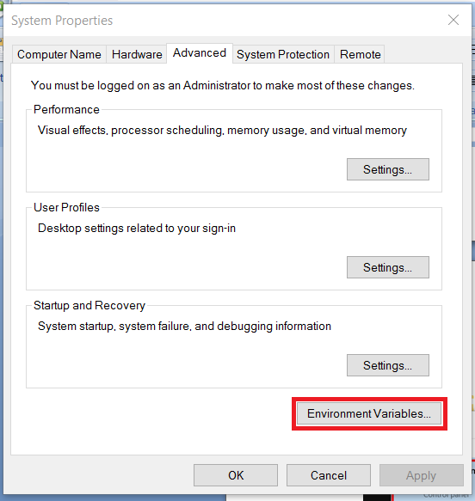 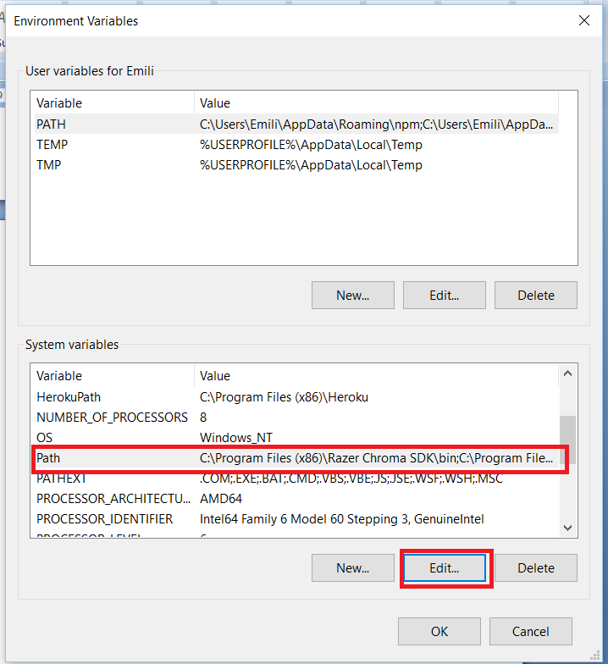

The control panel of the **System Properties** opens, under the **Advanced** section. **Environment Variables..** can be found there. Once clicked, another window called **Environment Variables** will open. In the **System variables**, **Path** has to be located, and then edited. Two new variables have to be added. The first one is the path to the Wamp's MySQL bin file. The file has to be located into the computer, as it is **C:\wamp\bin\mysql\mysql5.6.17\bin** in this case. The second one is the path to the Wamp's PHP file, as it is **C:\wamp\bin\php\php5.5.12** in this case. Once everything is set, the administrator has to click **OK** on all three windows, therefore saving the changes and closing the **Control Panel**.

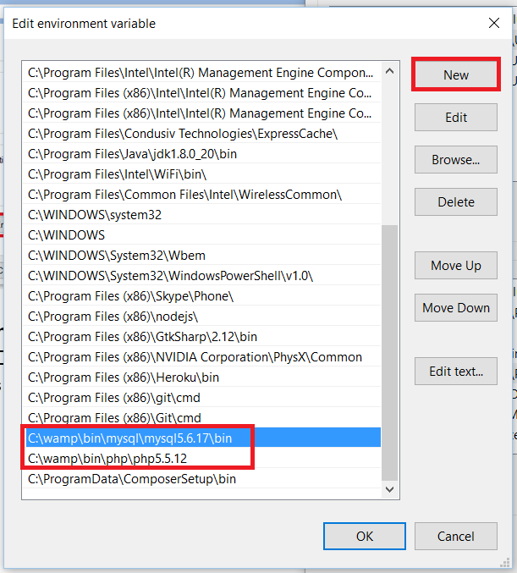

To make sure the path worked, the following commands have to be typed on the Command Prompt and the display should be similar to the following image, without any error message:

* **php -v**
* **mysql -u root -p** 
  + This one will ask for a password, the password is an empty string, therefore it is only necessary to click on **Enter** on the keyboard.

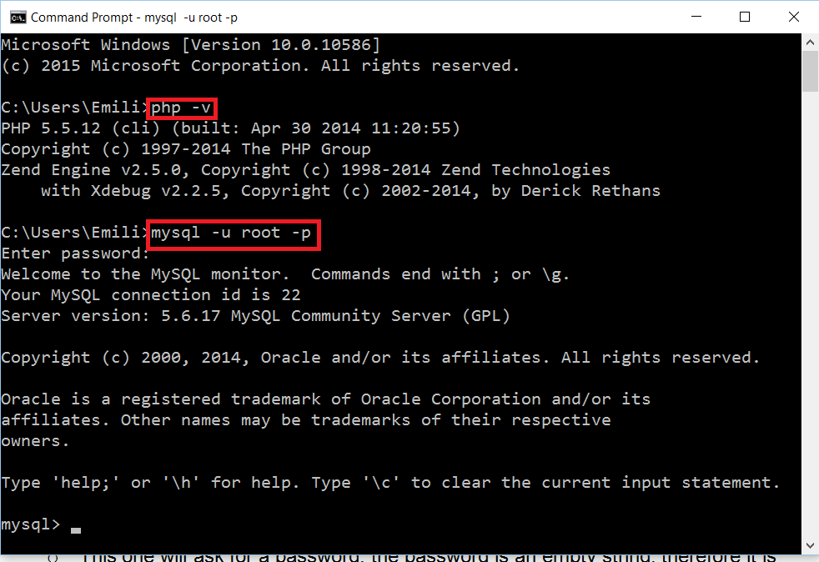

**Step 3: Turn on WampServer and Test the Connection**

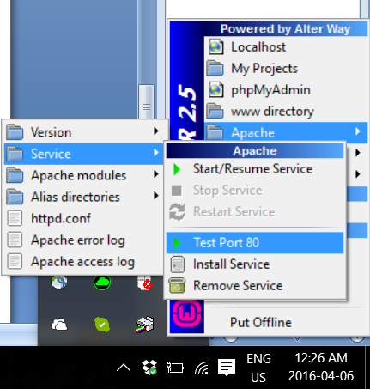First, Wamp has to be turned on. If the color does not turn green after clicking **Start All Services** and the color is stuck at orange, it is most likely because **port 80**. WampServer, as well for XAMPP, uses **port 80** for Apache. Therefore, this error is probably caused because another application is already using **port 80**. It is possible to test the connection by following this path on the Wamp application: **Apache > Service > Test Port 80**.

This is going to display an error if the port is really not available for Apache. As shown here, the error is usually caused by Skype being on at the same time, as both Apache and Skype use the same port. If it is the case, Skype has to be completely closed. It is then only sufficient to **Restart All Services** on Wamp, and the icon should turn green.

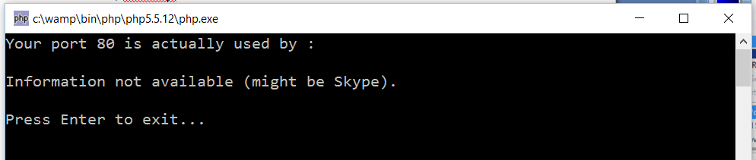

**Step 4: Download the project from GitHub**

The project has to be now retrieved from GitHub. This can be done from the following link: https://github.com/SOEN341/Schedule-Builder. As it is a zip file, the following has to be unzipped. The file can then be placed at any desired location.

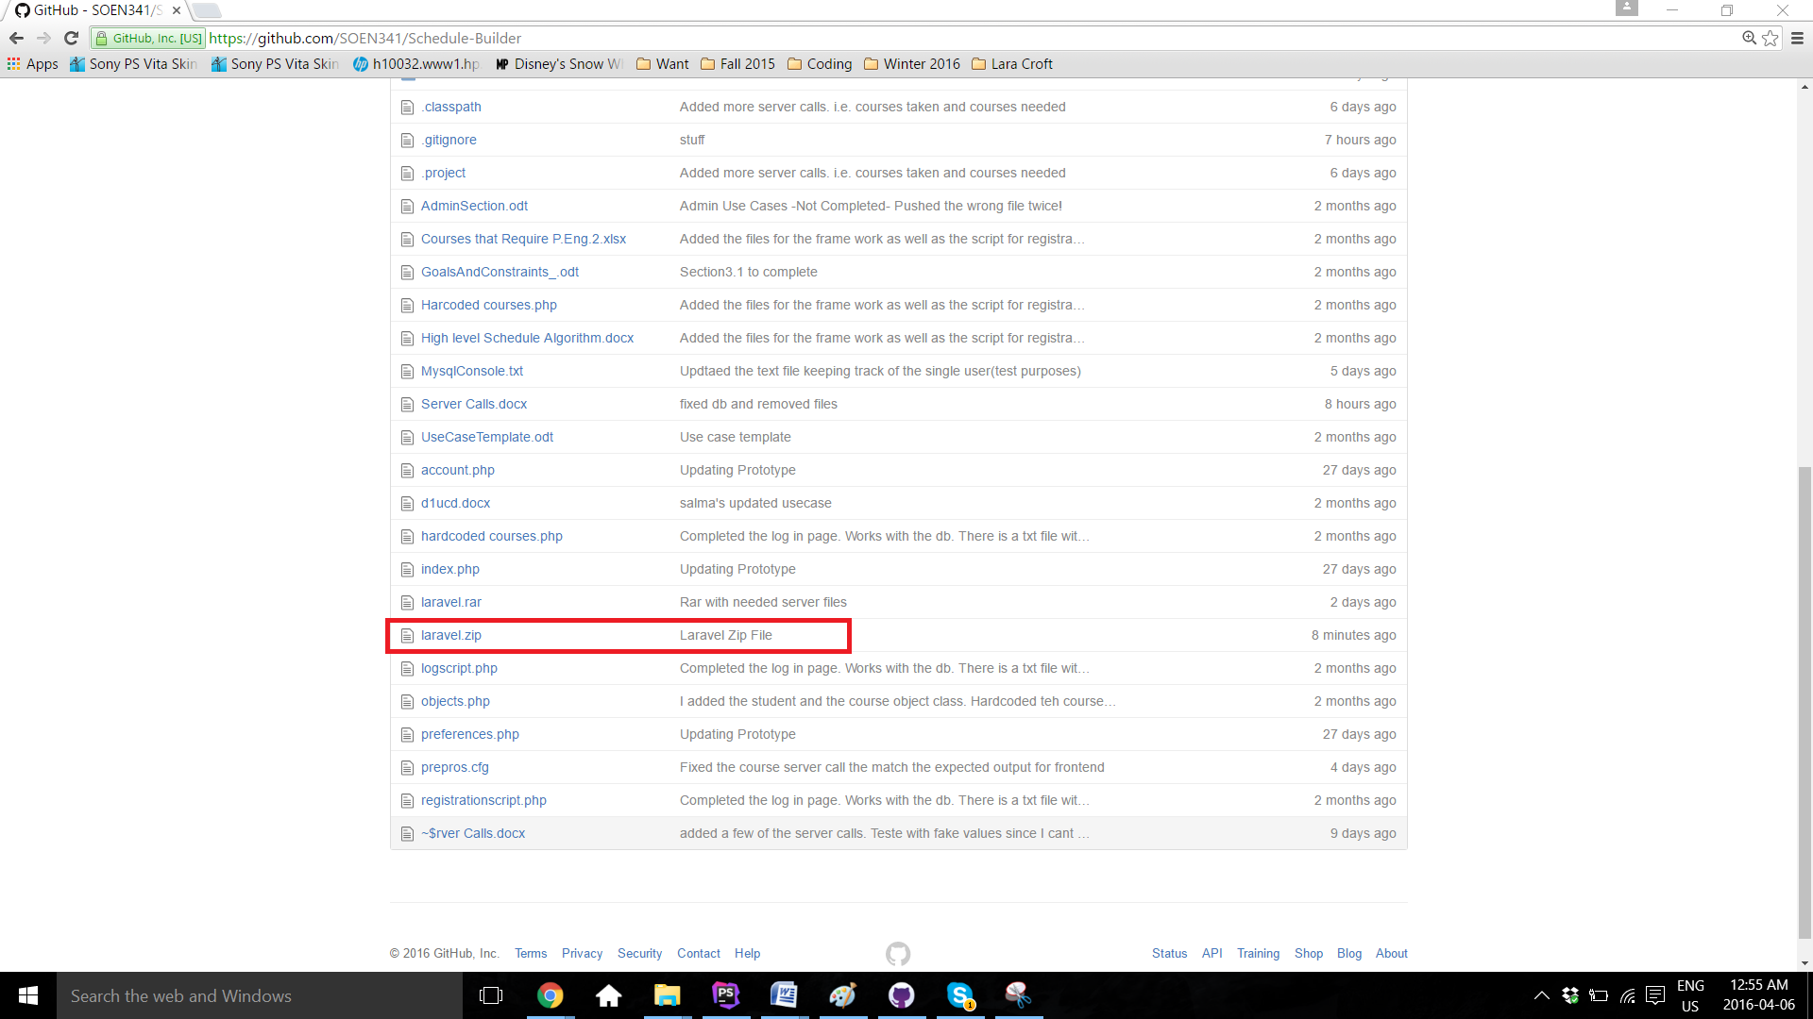

**Step 5: Set Database**

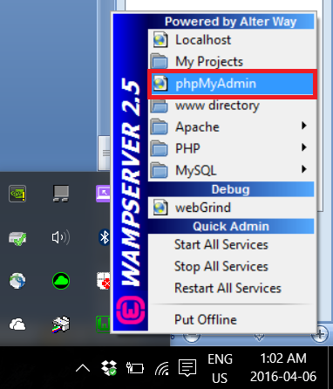

In order for the software to work, it has to be connected to the Database. From the **Laravel** file downloaded from GitHub, there is a file called **finaldbfile.sql**. This is the entire database of the project, containing all courses, sections, users information. This database has to be uploaded on MySQL on Wamp. To do this, **phpMyAdmin** has to be opened via Wamp.

**phpMyAdmin** will then open on the default browser. Then, the database has to be created, by clicking on **New**. The name of the database is **341db**.

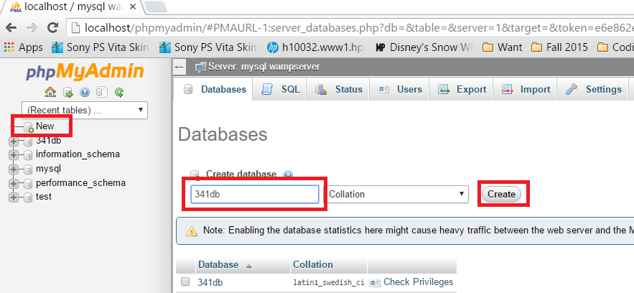

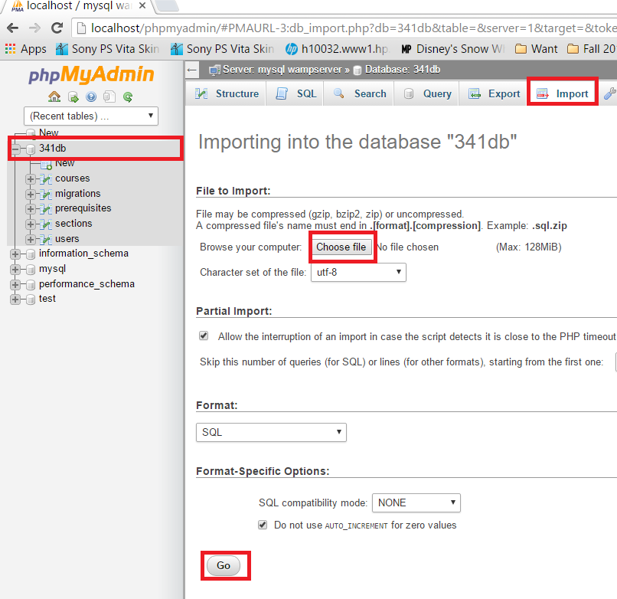Afterwards, **finaldbfile.sql** has to be imported onto the same **341db** database. On **phpMyAdmin**, 341db has to be selected, then **Import**, then **Choose file**. Navigate to the **Laravel** file and select **finaldbfile.sql**. Once the upload done, this section can be finalized by clicking **Go**. A green confirmation message will be displayed, saying the import has been successful.

**Step 6: Download and Install Compositor**

Compositor is a dependencies manager for PHP. This means that Compositor will handle all the needed libraries and files, in order to ease the development of the project. It can be download from https://getcomposer.org/download/. It is once again only necessary to follow the installation instructions. However, it is important keep track of where the Compositor gets the php.exe file from. It has to be from Wamp. If it is not the case, relocate the path to the **php.exe** inside of Wamp. The path is **C:\wamp\bin\php\php5.5.12\php.exe** for this case.

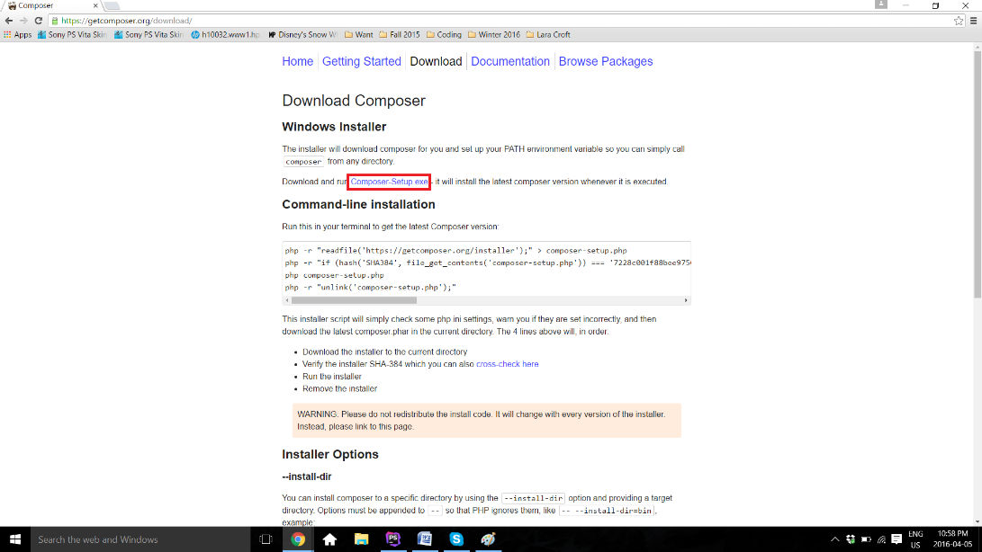

**Step 7: Download and Install MySQL**

Even though MySQL has been downloaded using Wamp, there seem to be some connection problem from Wamp if the software is not directly inside its **www** directory. To solve this problem, the original MySQL software is installed again, which helps to install MySQL correctly across the whole system. This allows the project to see the available MySQL throughout the system.

The software can be downloaded from https://dev.mysql.com/downloads/mysql/. The download can be found under **Community Server**. The desired OS can be picked (Windows in this case). **MySQL Installer 5.7 for Windows** is the desired version.

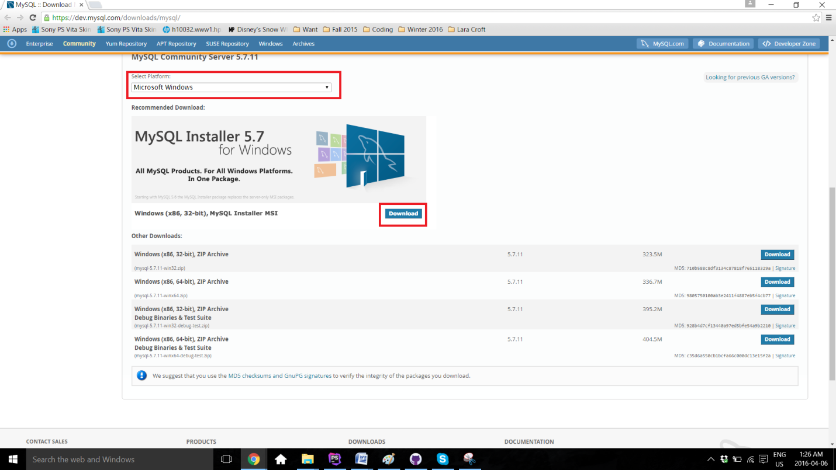

As any other past installation, it is only necessary to follow the instructions provided by the installer. Once installed, it is recommeded to test if MySQL is setup correctly, by typing **mysql --version** on **Command Prompt**.

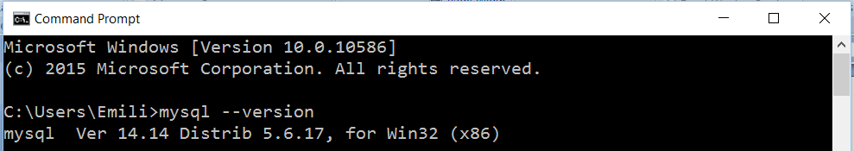

**Step 8: Run Scheduler Project**

Once everything is set up and Wamp is turned on and green, the project can now run. To do so, **Command Prompt** is used. The first command to type is **cd *project location\***. To navigate backward in folders, the command **cd..** does the trick. Once in the file of the project, the last command is executed: **php artisan serve**. The output **Laravel development server started on http://localhost:8000/** should be displayed.

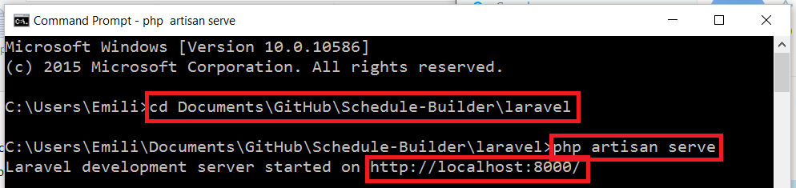

Now, it is only necessary to open a browser, and type **localhost:8000** in the URL bar.

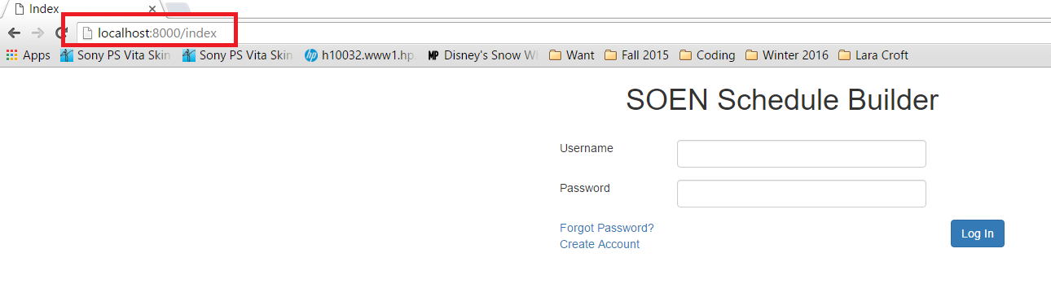

**3.2 User Manual**

The Scheduler is a system used by undergraduate software engineering students at Concordia University, which generates a class schedule based on the student’s record. It can be accesses from: https://schedule-heroku.herokuapp.com/index.

**Logging In**

Upon entering the website, a username and password will be needed to identify the user and allow access to the Scheduler. Returning users can simply login, while new users will be required to create a new account using the button “Create Account”.

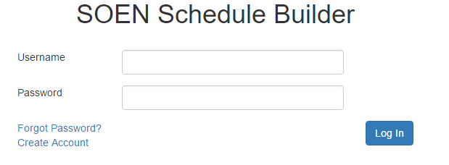

**Figure 1:** *Home Page*

**Resetting the Password**

If one of the returning users forgot their password, they can press the “Forgot Password?” link, which will allow them to reset their password by receiving a temporary one through e-mail. Successfully logging in will grant access to the menu page.

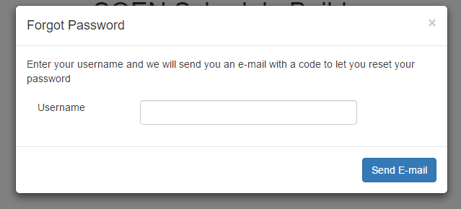

**Figure 2:** *Resetting Password*

**Account Creation**

When first time users click on “register”, the screenshot below will be shown. They will simply have to follow the instruction and fill out each box with the required information. Once this is done, the menu page will open.

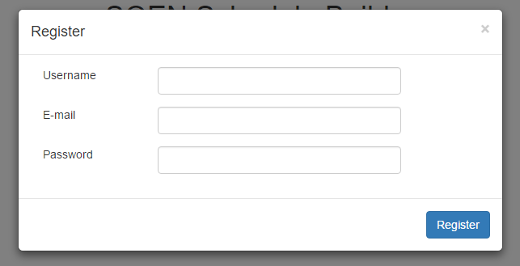

**Figure 3:** *Signing up*

The menu page is accessed after entering a valid username and password or after creating an account. This is where students make all their decisions concerning their schedule.

Here are the different actions users can choose in the menu page:

**Preferences:**

In this page, the users will first see when and where they would like to take courses. As seen in the screenshot below, the choices of having a day of the week off, taking classes in the morning afternoon or at night and the number of classes to take in the semester are all preferences to be set.

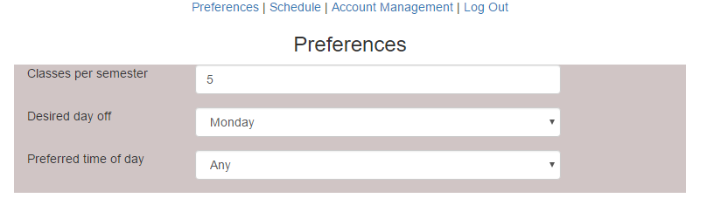

**Figure 4:** *Modifying preferences*

**Adding classes**

The preferences page also allows the students to input their taken courses as well as the needed courses.

One way to add the taken classes by choosing the semester already completed and generating a course list of all the courses that were offered. The user can then simply choose the courses he or she already completed.

The other method is by using the “Add Class” button and manually writing the course name number.

For the needed courses, the same concept is used. Using the “Add Class”, courses can be saved. Each of the saved courses can be edited or removed using the two icons located next to the course numbers.

Using the “build schedule” button seen at the bottom of the page, schedules will be generated and can be accessed in the “Schedule” page.

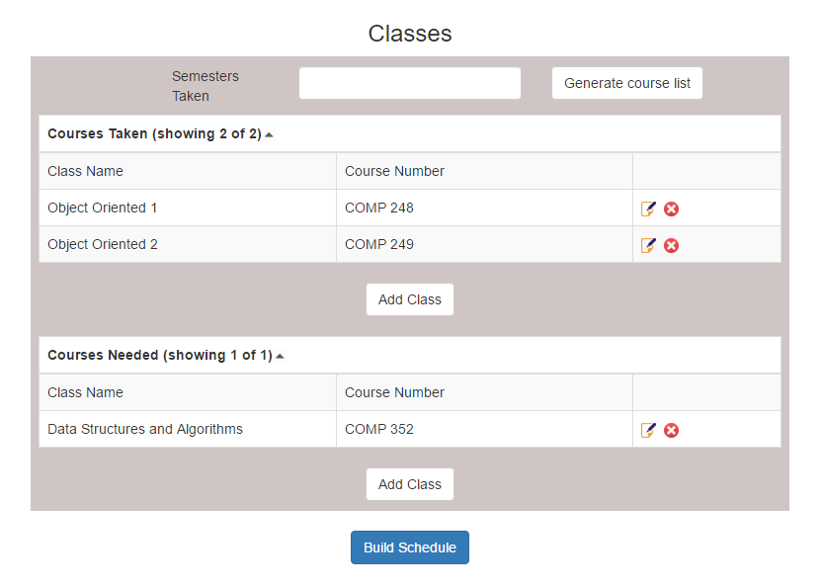**-**

**Figure 5:** *Adding courses*

**Account Management:**

By clicking on the account information link, users can modify their username, email or password (see figure 6).

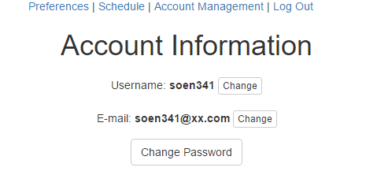

**Figure 6:** Account information

**Schedule:**

The schedule page is where all the possible schedules corresponding to user’s preferences are going to be generated. It is to be noted that the Scheduler needs the user to input all their taken and needed classes in order to generate a schedule.

The various schedules can be navigated by using the arrows at the top. When a schedule is deemed acceptable, it can be selected using the “Select This Schedule” button. Upon selecting a schedule, the sequence for the rest of the academic years will be created giving a guideline to follow (see figures below).



**Figure 7:** *Schedule*

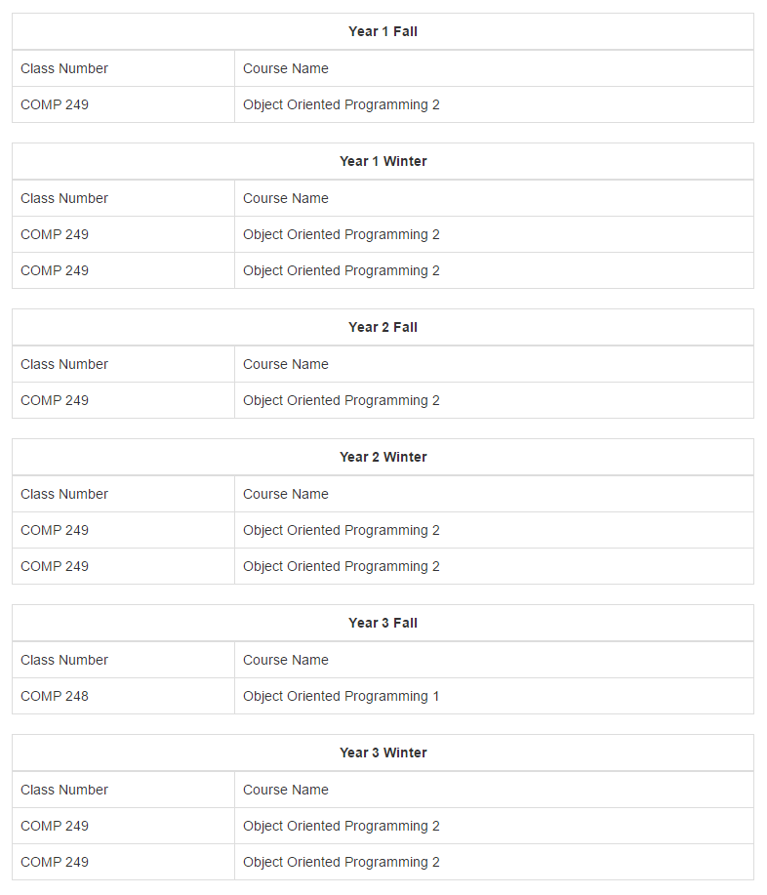

**Figure 8:** *Full sequence*

**\*Disclaimer:** The current state of the system is not completely functional and once all the issues are corrected, a full schedule will be displayed (which will be the case for the last deliverable). The screenshots are also going to be modified once the system is functioning properly.

**Logging out**

To log out, the “log out button” has to be pressed. This will exit the system bring the user back to the home page.

**3.3 Admin Manual**

The Admins access the website from the same domain name: https://schedule-heroku.herokuapp.com/index.

**Logging Page**

Upon entering the website, a username and password will be demanded. Admins should have a special login username and password to enter the website specifically designed for them.

If the password is forgotten, by clicking on “Forgot Password”, it can easily be recovered.

Successfully logging in brings the Admins to the main page of the website.



Figure 9: Home Page

The Admins can add or edit courses present in the database. Entering this page provides the Admins with a whole list of the courses.

**Adding a Course**

In order to add a course, the button “add class” is to be pressed. This will provide the Admins with a form to fill. More specifically, entering the course number, name and the semester.

**Adding/Modifying Information and Sections**

Next to courses seen on the page, there is a small icon showing a paper and a pencil. By pressing it, it allows the admins to change the descriptions of the course or its number. Also, by clicking on the course name, the different sections of the course are displayed. The same paper and pencil icon can be pressed to modify the time of the sections and the classroom.

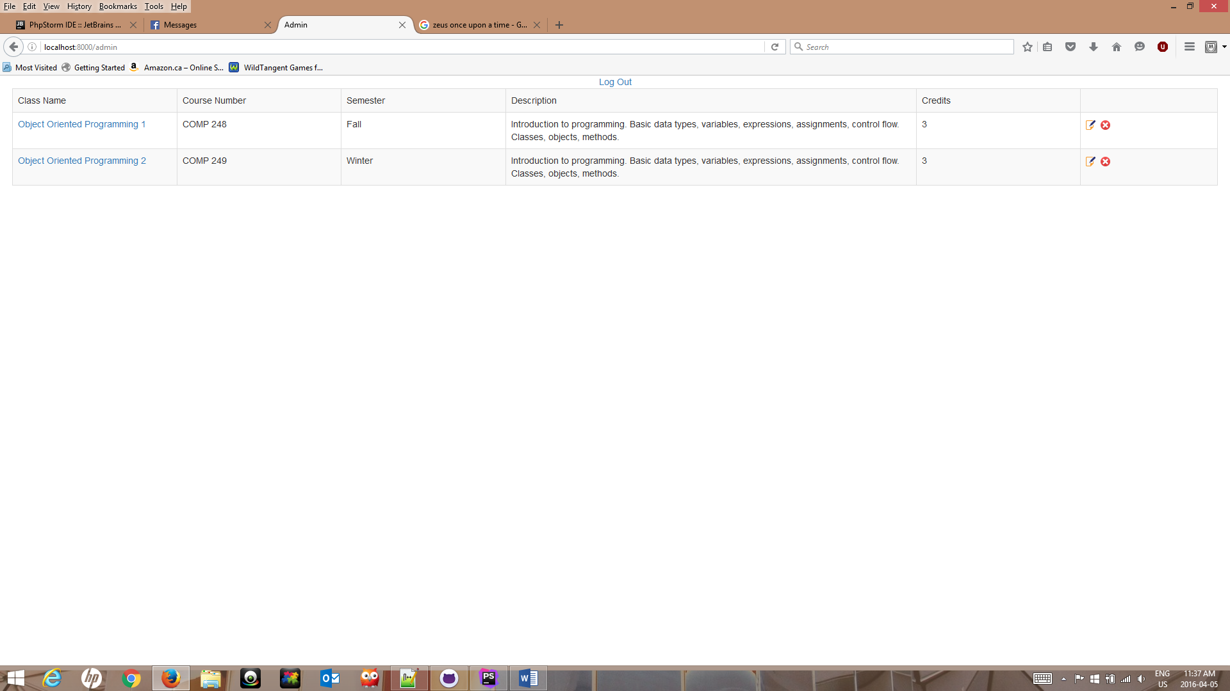

Figure 10: Course list

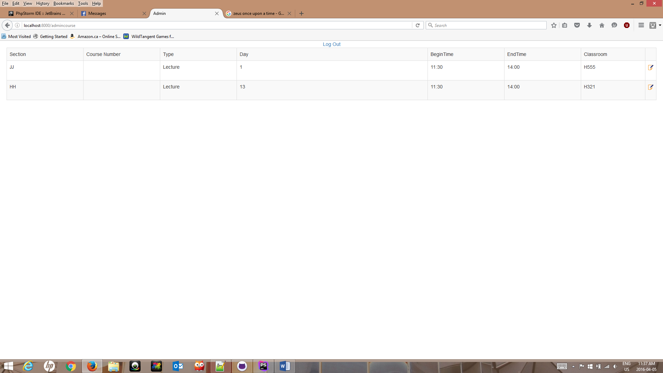

Figure 11: Class Sections

**Log Out**

To log out, Admins can press the “log out” button at the top of the page.

4. Final Cost Estimate

A number of design and testing aspects were overlooked during our initial estimate. In the first deliverable, tasks such as creating the database, and ensuring that the system would be able to perform the necessary read and write operations were slightly underestimated. Testing was also

The total project cost estimate as calculated to date is detailed in the table below. A side by side comparison between the original estimated cost and the actual cost illustrates the difference in hours that our team need to make adjustments for.

|  |  |  |  |
| --- | --- | --- | --- |
| **Artifact** | | **Estimated Cost in Hours** | **Final Cost in Hours** |
| **Deliverable0** | | **5** | **5 ($125)** |
| **Deliverable1** | | **70** | **70 ($1750)** |
| **Deliverable2** | |  |  |
| **4+1 Architectural**  **View** | **Logical** | **10** | **10** |
| **Development** | **3** |
| **Physical** | **3** |
| **Process** | **5** |
| **Scenarios** | **1** |
| **Subsystem Interface Specification** | | **25** | **20** |
| **UML Class Diagram** | | **12** | **10** |
| **Dynamic Design Scenario** | | **6** | **10** |
| **Estimation** | | **7** | **5** |
| **Rapid Prototyping Report** | | **22** | **25** |
| **Testing** | | **15** | **15** |
| **Risks** | | **4** | **4** |
| **Total Hours** | | **101** | **111** |
| **Cost Estimate ($25/hr)** | | **$2525** | **$2775** |
| **Deliverable3** | |  |  |
| **Database Creation** | | **20** | **20** |
| **Web Interface Design** | | **20** | **16** |
| **Database interaction & Server calls** | | **20** | **14** |
| **Unit Testing** | | **20** | **30** |
| **Requirement Testing** | | **20** | **20** |
| **Stress Testing** | | **8** | **10** |
| **Security Testing** | | **7** | **7** |
| **Installation** | | **Unaccounted for** | **10** |
| **Installation Manual** | | **6** | **12** |
| **User’s Manual** | | **6** | **8** |
| **Administrator manual** | | **Unaccounted for** | **2** |
| **EStimation** | | **4** | **3** |
| **Total Hours** | | **129** | **152** |
| **Cost Estimate ($25/hr)** | | **$3225** | **$3800** |

An additional cost of 23 hours has been incurred during the realization of the third deliverable bumping the cost from an estimated $3225 to an actual $3800. A 50hours estimate is still projected for the realization of the final deliverable as per our initial calculations mainly due to the adjustments that are to be made in order to correct t and adjust the aspects of the project that were deemed unsatisfactory.

It is therefore our estimation that the total cost of the project will be increased by $575 which corresponds to the difference between the estimated and actual cost incurred for the realization of deliverable3.

The final cost jumps from the $9050 estimated at the end of deliverable2 to $9625.